IT226 Biotechnology Lab 1

Fall 2016

Reflection 1

Due Thursday, September 15

1. How would you describe the process of research?

Research is the investigation of a topic or a question that has no known answer or explanation. Before performing a research project, the researcher finds more information about the topic to determine the best way to focus and guide the project. The researcher would find the proper materials and resources to perform the project, and then perform the project, keeping accurate documentation. The researcher then reports their findings to the public.

1. Would you describe what you have done thus far in class as research? Why or Why not?

I would describe what I have done thus far in class as research, as I have learned about what I am researching—new bacteriophage—and the techniques I am using to do the research. I have also learned how to keep accurate documentation.

1. How would you describe the project you are working on this semester to someone outside of class in 2-3 sentences?

In this class, I am learning microbiological laboratory techniques in order to discover a new bacteriophage. After isolating a species from a collected sample, the genome of the phage will be annotated and analyzed.

1. If students isolate and sequence the DNA of phages from different sites nationwide, what kinds of research questions can be answered with the data they collect, assuming they record all the requested sampling information?
   * *Note: In lab, be sure to include all of your sample data in your lab notebook, including a picture of the sample site and your GPS coordinates, so your data can contribute to the national initiative and help address broad research questions beyond Purdue*

Research questions about phage relationships, such as “To what degree are phage from the same region related compared to phage from different parts of the country?” and “Are phage collected in very moist environments related to each other to a higher degree than those in very dry environments?” can be answered.

1. What did you accomplish this week? Your answer should include a summary of your findings.
   * Reflect on the meaning and/or implications of your findings for the work that you have done in lab thus far. Refer to the data or evidence that you have to support any claims that you make. Or, more specifically, did you find a plaque? If so, what were the characteristics of that plaque? Do you think it is a lytic or a temperate phage? What data/evidence do you have to support your conclusions?
   * *Note: During lab, make sure you take a picture and document both positive and negative results and label your evidence clearly in your notebook. You need to document the outcomes from each sample you process-----remember----if you don’t document it, it didn’t happen.*

This week, a second plaque was picked from my third sample’s plaque assay. The first plaque that was picked had an illogical infection pattern on the serial dilution plaque assays. The plaque, labeled B picked was round, about 2 mm across, and clear with very small bubbles or spots in them, so I believe it to be a lytic phage. On Tuesday, the plaque was picked, a serial dilution was performed, and the dilutions were plated and cultured. On Thursday, the serial dilution plaque assays were inspected and determined to have a logical infection pattern. The 10^-2 dilution plate was flooded and the 10^-3 dilution plate was wrapped and saved for future use.

1. What issues or challenges did you face this week?

My partner and I faced challenges in determining whether to flood a plate. Our first plaque assay of a serial dilution did not have a logical infection pattern, as the most infected plate was that with the 10^-5 dilution, while the 10^-1 dilution had little to no plaques. Thus, we had to pick another plaque and re-perform the serial dilution to ensure that the plaque was not due to contamination.

1. What are your goals and plans for the upcoming week?

My plan for next week is to harvest a plate lysate and then calculate the titer of my lysate with the spot titer protocol.

1. State 1-2 questions that you have about the results, the activities/experiments, and/or the research project.

* How will the results of the project be reported to the SEA-PHAGES project?
* How do we know we have discovered a new phage, rather than one that has already been discovered?

1. What is the difference between a lytic phage and a temperate phage?

A lytic phage replicates via the lytic cycle and temperate phages can replicate with both the lytic and the lysogenic cycles.

1. Can you tell if a phage is likely to be lytic or temperate based upon the morphology of the plaque? Looking at the figure below, can you make a guess about which phage (left or right plate) is likely to be lytic and which is likely to be temperate? Provide a rationale to support your answer.

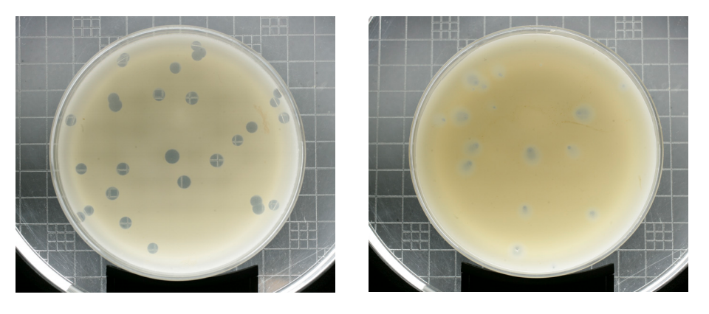

The figure to the right is temperate, as the plaques are cloudy and irregularly shaped, as the lysogenic cycle allows the host to live and reproduce normally while the virus reproduces. The figure to the left is lytic, as the plaques are round and clear, as the lytic cycle kills the host bacteria after the lytic cycle is complete.

1. The filters you are using in lab to process samples are “0.22 μm.” What’s the significance of “0.22 μm” relative to the things that might be present in the supernatants?

The significance of 0.22 μm is the fact that most bacteria are 2-8 μm in length, while most viruses are 0.20 μm in length, which allows viruses and not bacteria to pass through the filter.